

TRAFFIC REGULATION NOTICE
ROAD TRAFFIC REGULATION ACT, 1984

Notice is hereby given pursuant to Section 14(2) of the Road Traffic Regulation Act, 1984, that the Oxfordshire County Council

TEMPORARY ONE-WAY RESTRICTION
(Two-way traffic to One-way)

LOCATION: Faringdon, Church Street (26 to 34 Church Street)

REASON: To facilitate excavation across the road and electrical installation for new customer

DURATION: Starting on 18 January 2021
The anticipated completion date is 22 January 2021. This is a 24 hour two way to one way.
(Traffic Regulation Notices cover a maximum of 5 consecutive days)

SUGGESTED ALTERNATIVE ROUTE: via Church Street, Swan Lane, London Street and Coach Lane
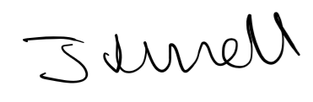
Jason Russell, Corporate Director - Communities
Date: 15 December 2020

