TRAFFIC REGULATION NOTICE
ROAD TRAFFIC REGULATION ACT, 1984

Notice is hereby given pursuant to Section 14(2) of the Road Traffic Regulation Act, 1984, that the Oxfordshire County Council

TEMPORARILY PROHIBITS THE USE OF THE HIGHWAY
BY ALL MOTOR VEHICLES

LOCATION: Little Worth & Great Faringdon, Thrupp Turn

REASON: Installation of BT poles (poling lorry and drill)

DURATION: Starting on 26 May 2020
The anticipated completion date is 28 May 2020
(full closure 24hrs each day)

(Traffic Regulation Notices cover a maximum of 5 consecutive days)

ACCESS: Limited access will be maintained for emergency service vehicles and for frontages within the closed section of road, subject to the progress of the works

SUGGESTED ALTERNATIVE ROUTE: The alternative routes for traffic are via a combination of Redcot road – London Street – A420 – Unnamed Road towards Little Worth and vice-versa.

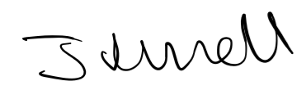
Jason Russell, Director for Infrastructure Delivery
Communities

Date: 16 March 2020

