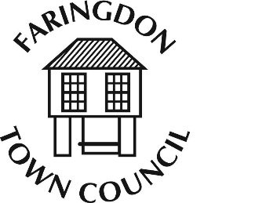**FARINGDON TOWN COUNCIL**

The Pump House, 5 Market Place, FARINGDON, Oxfordshire, SN7 7HL

Telephone 01367 240281

[www.faringdontowncouncil.gov.uk](http://www.faringdontowncouncil.gov.uk)

Clerk: Sally Thurston

The Parish of Great Faringdon

In the County of Oxfordshire

# NOTICE OF A TOWN MEETING

**MONDAY 2nd December 2019 at 7.30 p.m.**

**in the Corn Exchange, Faringdon**

## AGENDA

1. **Mayor’s Opening Address**
2. **Apologies for Absence**
3. **Minutes of the Town Meeting held on MONDAY 20th May 201**
4. **Matters Arising**
5. **Town Council Budget and Precept for 2020/21**
6. *To receive presentations on the proposed budget for 2020/21 from Council Committee Chairmen*
7. *To receive suggestions from residents for additional projects to be considered.*
8. **Climate Change Update**
9. **Public Speaking Time and General Discussion**

