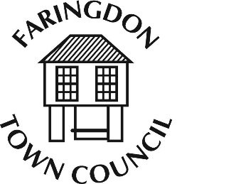**FARINGDON TOWN COUNCIL**

The Pump House, 5 Market Place FARINGDON, Oxfordshire, SN7 7HL Telephone 01367 240281

[www.faringdontowncouncil.gov.uk](http://www.faringdontowncouncil.gov.uk)

Clerk: Sally Thurston

**Members of the Community and Partnerships Committee. You are summoned to attend Community and Partnerships Committee meeting to be held on Wednesday 6th November 2019 at 7pm in the Jubilee Room, the Pump House, Faringdon. Press & Public are invited to attend.**

**AGENDA**

|  |  |
| --- | --- |
| **1.** | **Apologies for Absence** |
| **2.** | **Minutes of last meeting** – Tuesday 8th October 2019 |
| **3.** | **Declarations of Interest**  *Members are reminded of their responsibility to declare any disclosable pecuniary interest which they may have in any item of business on the agenda no later than when the item is reached. Unless dispensation is granted, you must withdraw from the room when the meeting discusses and votes on the matter.* |
| **4.** | **Public Question and Speaking Time**  *Questions will be restricted to one from each member of the public, or a maximum of three per meeting. Written notice of questions must be received by the Clerk at least 3 working days before the meeting.*  *Members of the public are welcome to speak on any business itemised on the agenda for up to 3 minutes* |
| **5.** | **Precept 2019/20**   1. To receive a financial report 2. To consider draft budgets for 2020/21 3. To consider capital expenditure projects for 2020/21 |
| **6.** | **Items for Information Only** |
| **7.** | **Be Free Young Carers**  To consider a recommendation from the Grants Sub Committee to award a grant of £1600 to Be Free Young Carers from the Youth Grants Fund. |
| **8.** | **Art Workshops**  To receive an update |



Date: 31st October 2019