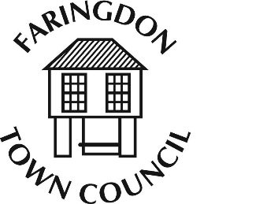
FARINGDON TOWN COUNCIL
The Pump House, 5 Market Place , FARINGDON, Oxfordshire, SN7 7HL
Telephone 01367 240281
www.faringdontowncouncil.gov.uk
Clerk: Sally Thurston

Grant Sub - Committee
Committee Membership

Members: 5 Members of the Finance and Audit Committee to include the Mayor and Deputy Mayor

Quorum: 3

Terms of Reference
Adopted by Council:

- To give careful consideration to the approval of grant applications.

- To be responsible for setting and managing policy and procedures for the awarding of grants

- Monitor grants awarded against the annual budget set by the Finance and Audit Committee and approved by Full Council.

- To report regularly to the Finance and Audit Committee

