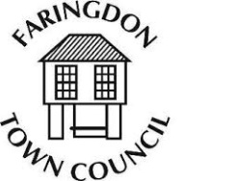
Faringdon in Bloom 2019
Application Form
All entries must be received by Friday 14th June 2019. To enter please email a completed form to adele@faringdontowncouncil.gov.uk
Or returned to the Town Council offices
THE PUMP HOUSE, MARKET PLACE, FARINGDON, SN7 7HL
For further information please call 01367 240281
Name:
Address:

Email Address:

Telephone Number:

Which categories do you wish to enter?
Best Large garden

Best small garden

Best allotment

Best wildlife garden

Best patio/courtyard garden

Best new garden

Best junior miniature garden

Best business basket / box

Best business floral display

Best junior miniature garden

Joy to the Community

Address of garden or display if different from contact:
Address:

Contact number:

All entries must be able to provide access for the judges 21st, 22nd and 23rd of June 2019
Junior miniature gardens must be delivered to the Corn Exchange by 12:30am on the 23rd of June clearly labelled with the name and age of the child
Presentation of prizes and junior miniature garden judging will take place at approximately 1pm on Sunday 23rd of June 2019
To enter a garden, you must either own the property, be renting the property or have consent from the owner. By entering you are agreeing you have consent.

The Judge’s decisions are final.

