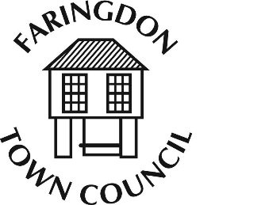
FARINGDON TOWN COUNCIL
The Pump House, FARINGDON, Oxfordshire, SN7 7HL
Telephone 01367 240281 Fax 01367 240303
www.faringdontowncouncil.gov.uk
Clerk: Sally Thurston

The Parish of Great Faringdon In the County of Oxfordshire

NOTICE OF ANNUALTOWN MEETING
MONDAY 21st May 2018 at 7.30 pm
in the Corn Exchange, Faringdon
The meeting will be preceded by the Community Awards at 6.30pm

AGENDA

- Mayor’s Opening Address

- Apologies for Absence

- Minutes of the Town Meeting held on 22nd January 2018

- Matters Arising

- Reports
The following reports will normally be in the form of a written report and will be discussed only if townspeople have questions or comments.

- Reports from Town Council Committees

- Reports from
- Tucker’s Recreation Ground Trust
- Faringdon War Memorial Trust

- County Councillor’s Report

- District Councillors’ Report

- Reports from Local Organisations

- Public Speaking Time and General Discussion

4th May 2018 Signed:
Cllr. Dr. Mike Wise

THIS IS A MEETING OF THE ELECTORS OF FARINGDON, NOT A MEETING OF THE TOWN COUNCIL

ALL ELECTORS ARE WELCOME, AND MAY SPEAK AND VOTE

ON ANY MATTER DETAILED IN THE ABOVE AGENDA

