**Faringdon Town Council**

**Faringdon Elms Tennis Association**

**This is a public tennis and if you would like to buy a key please email:** [**cmurphy@brookes.ac.uk**](mailto:cmurphy@brookes.ac.uk) **or alison.scott@sodexo.com**

MC900230177[1]

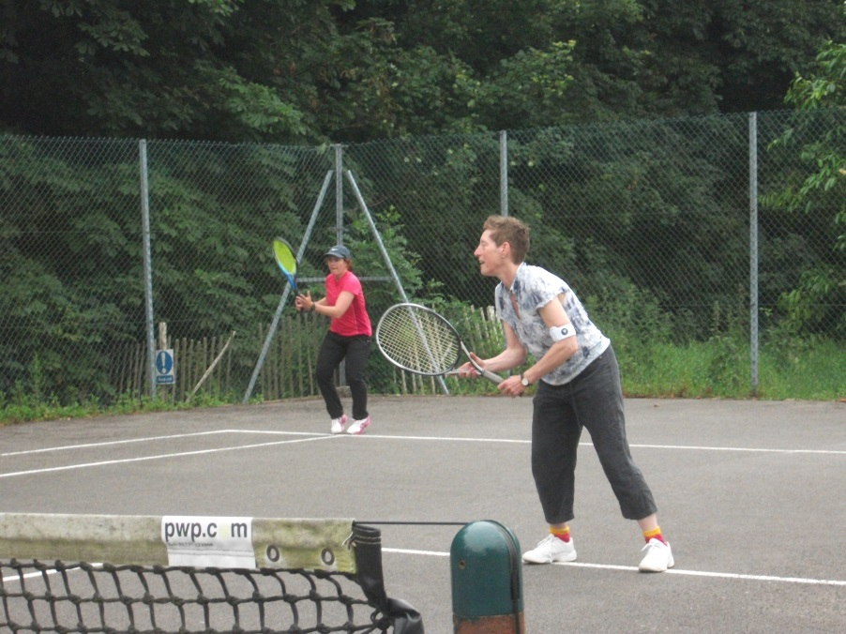

This is the public tennis court in Faringdon managed by a group of volunteers on behalf of The Faringdon Town Council.

It is for the benefit of people in and around Faringdon who wish to play tennis on a casual basis. As Faringdon gets more populated with houses it is good to see that we can still keep our ‘open spaces’ for the general health and well-being of the residents.

We are very much looking forward to ensuring that we can look after the court and attract lots of new players young and old.

Please contact Carolyn Murphy or Alison Scott with any queries. If you wish to join us on the steering group to help the future direction of the court you would be most welcome.