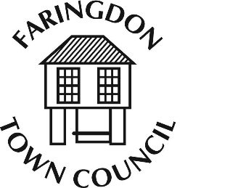
FARINGDON TOWN COUNCIL
The Corn Exchange, FARINGDON, Oxfordshire, SN7 7JA
Telephone 01367 240281 Fax 01367 240303
www.faringdontowncouncil.gov.uk
Clerk: Sally Thurston

Recommendation from P&H Committee in respect of the Faringdon Parking Survey currently being carried out by Gary Kay Smith Limited.

Planning & Highways Committee recommends that Town Council accepts the Faringdon Parking Survey Draft Executive Summary & Recommendations & First Draft Report. (Please note, members of the Planning & Highways Committee have already received copies of these documents last week.) Subject to approval by Town Council, the report will then be presented by Gary Kay Smith Limited to VWHDC for its comment and approval.

The report will to go out to public consultation at the Town Meeting on 26th January. Gary Smith will be able to attend this meeting to present the report.

