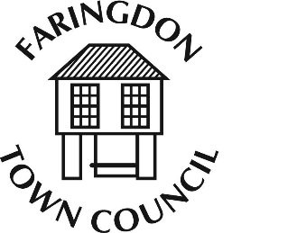
FARINGDON TOWN COUNCIL
The Corn Exchange, FARINGDON, Oxfordshire, SN7 7JA
Telephone 01367 240281 Fax 01367 240303
www.faringdontowncouncil.gov.uk
Clerk: Sally Thurston

YOUTH SERVICES COMMITTEE
Committee Membership
Members: The Committee will consist of eight members including, ex officio, the Mayor and Deputy Mayor
Quorum: 3
Terms of Reference
Adopted by Council: Wednesday 9th September 2015
- The Committee will set a budget annually for consideration by the Finance and Audit Committee and monitor its financial performance against the annual budget previously agreed by the Council.
- The Committee will be responsible for managing the FAZE Youth Centre by:
  - keeping the existing provision of staff and facilities at the Centre under review and introducing changes to meet future needs as and when they become necessary,
  - ensuring that the legal requirements involved in dealing with young people, including the provision of a Safeguarding Officer, are met,
  - requiring regular progress reports from the senior youth worker,
  - arranging the purchase of appropriate equipment for the Centre and ensuring that all equipment on the premises is properly maintained,
  - determining the qualification levels for youth workers and agreeing their training programme, and
  - ensuring that all health and safety requirements are met.
- The Committee will coordinate the funding of youth and community projects by arranging the distribution of funds obtained from external funding bodies to local groups involved in supporting young people.
- The Committee will consider all matters referred to it by the Council and, where appropriate, will recommend suitable courses of action on these.

