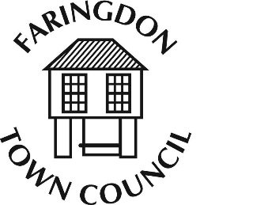
FARINGDON TOWN COUNCIL
The Corn Exchange, FARINGDON, Oxfordshire, SN7 7JA
Telephone 01367 240281 Fax 01367 240303
www.faringdontowncouncil.gov.uk
Clerk: Sally Thurston

VENUES COMMITTEE

Committee Membership
Members: The Committee will consist of eight members including, ex officio, the Mayor and Deputy Mayor
Quorum: 3
Terms of Reference
Adopted by Council: Wednesday 9th September 2015

- The Committee will meet a minimum of five times per year.
- The Committee will set an annual budget for consideration by the Finance and Audit Committee and monitor its financial performance against the budget previously agreed by the Council.
- The Committee will be responsible for managing and maintaining the following venues
  - The Corn Exchange
  - The Pump House
- The Committee will be responsible for setting fees and charges to maximize income whilst maintaining the venues as community facilities.
- The Committee will be responsible for agreeing and reviewing terms and conditions of hire of the above venues.
- The Committee will ensure that any equipment available for staff use is properly maintained.
- The Committee will ensure all health and safety requirements are met.
- The Committee will consider all matters referred to it by the Council and, where appropriate, will recommend suitable courses of action on these.
- The Committee will consider any future proposals for the acquisition or disposal of venues within the parish of Great Faringdon and make recommendations to Council.

