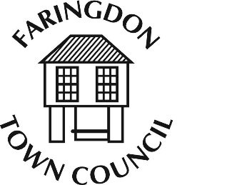
FARINGDON TOWN COUNCIL
The Corn Exchange, FARINGDON, Oxfordshire, SN7 7JA
Telephone 01367 240281 Fax 01367 240303
www.faringdontowncouncil.gov.uk
Clerk: Sally Thurston

Finance and Audit Committee
Committee Membership
Members: Chairs of all committees, Mayor, Deputy Mayor plus 3 council members.
Deputies: If the chair of a committee cannot attend then the vice chair of the committee can act as substitute.
Quorum: 5

Terms of Reference
Adopted by Council: Wednesday 9th September 2015
- To exercise management of the Council’s finances and reserves.

- To give careful consideration to the acceptance of leases and contracts.

- To set an annual budget and monitor financial performance against the budget previously agreed by the Council for:
  - Office and Establishment
  - Direct Council Expenditure
  - Community and Tourist Information Centre
- To consider recommendations from committees for their annual budgets to form part of the annual precept request.
- To make a recommendation to Full Council for the annual precept request.
- To consider the approval of grant applications.
- To be responsible for setting and managing policy and procedures for:
  - Audit – both internal and external
  - Health and Safety
  - Risk Management

- To be responsible for the overall management of the Community and Tourist Information Centre.

- The committee has overall responsibility for the management of Human Resources. This will be carried out via the Town Clerk and a Staff Working Party which will report to the Finance and Audit Committee.

